Slope of a Line

Key Points:
- Slope is a rate of change. The slope of a linear function can be calculated by dividing the difference between y-values by the difference in corresponding x-values of any two points on the line.

- An increasing linear function results in a graph that slants upward from left to right and has a positive slope. A decreasing linear function results in a graph that slants downward from left to right and has a negative slope. A constant linear function results in a graph that is a horizontal line.

- Given two points $\left(x_{1},y_{1}\right)$ and $\left(x_{2},y_{2}\right)$ from a linear function, we can calculate and interpret the slope $m$ according to the following:

  - Determine the units for input and output values.
  - Calculate the change of output values and change of input values.
  - Interpret the slope as the change in output values per unit of the input value, according to this equation:

$m=\frac{change in output (rise)}{change in input (run)}=\frac{∆y}{∆x}=\frac{y_{2}-y_{1}}{x_{2}-x_{1}}$

- Given the graph of a linear function, we can write an equation to represent the function according to the following:

  - Identify two points on the line.
  - Use the two points to calculate the slope.
  - Determine where the line crosses the y-axis to identify the y-intercept by visual inspection.
  - Substitute the slope and $y-$intercept into the slope-intercept form of a line equation ($y=mx+b$, where m is the slope and b is the $y$-intercept).

Slope of a Line Video
- Finding a Slope of a Linear Function
- Writing an equation for a Linear Function from a graph of a Line
- Finding an equation for a Linear Function Given Two Points

Practice Exercises

Follow the directions for each exercise below:

- Find the slope of the line shown in the graph:
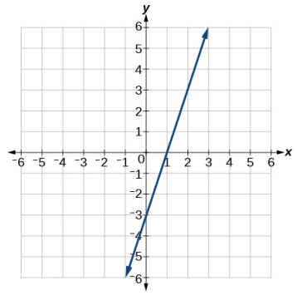
- Find the slope of the line shown in the graph:
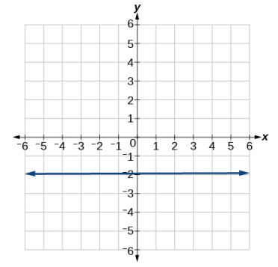

- Write an equation in slope-intercept form for the line shown in the graph:
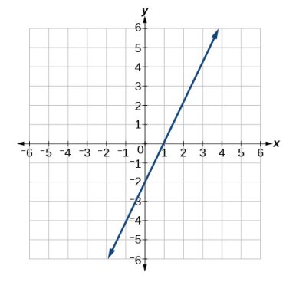

- Find the slope of the line that passes through the two given points:$\left(1,5\right) , (4,11)$

- Find the slope of the line that passes through the two given points:$\left(8,-2\right), (4,6)$

- Write an equation for the line graphed:

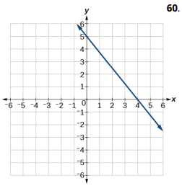

- Write an equation for the line graphed:
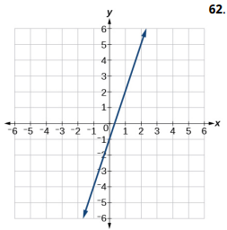

- Write an equation for the line graphed:
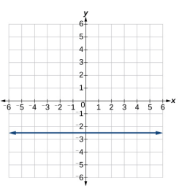

Answers:
- $3$

- $0$

- $y=2x-2$

- $2$

- $-2$

- $y=-\frac{5}{4}x+5$

- $y=3x-1$

- $y=-2.5$

